Titan’s Direct Mobile Application

Project Plan

Alex Lindemann, Devon McLean, Kyle Green

18 October, 2021

# Table of Contents

**Table of Contents** **1**

**1. Introduction** **2**

a. Scope and Purpose 2

b. System Scope 2

i. Problem Description 2

ii. Anticipated Business 3

iii. System Capabilities 3

iv. System Context 4

**2. Schedule** **5**

**3. Staff Organization** **6**

a. Team Structure 6

**4. Tracking and Control Mechanisms** **6**

# 1. Introduction

## a. Scope and Purpose

(KG)

The purpose of this document is to explain the purpose as well as to outline the intended process to create a mobile application for Titan’s Direct. The following document is broken into several stages to better understand the software development process.

The purpose of the application is to create a more mobile friendly, streamlined process for students to access and better utilize Titan’s Direct. The application will include a small list of features at launch, and will be expanded in the future to include a number of additional features to aid in benefitting students and other users of the application.

## b. System Scope

### i. Problem Description

(KG)

Titan’s Direct is a web tool that allows students of the County College of Morris (CCM) to access grades, view and schedule classes, and take care of financial needs. As far as the desktop experience is concerned, there are next to no issues with the tool for the basic user. However, the mobile experience leaves much to be desired.

From a basic user’s perspective, the mobile experience is cluttered, disjointed, and often has issues translating large desktop items, such as the course calendar and student transcripts, to a smaller mobile screen. The goal of the Titan’s Direct Application (TDA) is to alleviate these concerns as well as offer some additional quality of life features to a mobile application for students of CCM.

### ii. Anticipated Business

(KG)

With the creation of this application, the company hopes to give students a more streamlined mobile experience for using Titan’s Direct. Given the current state of the mobile web tool, there are a plethora of potential fixes that this application could include, with a number of these solutions included in a future section (1.b.iii)

The app will include several “fixes” to the mobile experience, and allow for students to have an easier time navigating not only through Titan’s Direct, but also aiding in benefitting their overall experience while on campus. With current issues including poor translation of various desktop elements to mobile, the TDA will allow users to have a much easier time digesting these desktop elements in an app designed for mobile devices.

### iii. System Capabilities

(KG)

The following features are set to be included upon initial release:

* Student ID - Users will have access to a digital ID card on their mobile device, complete with photo ID and their student ID code.
* Grades - Users will have the ability to access past grades and a calculated estimate of current course grades along with grades of individual assignments.
* Course Schedule - Users will have access to all of their currently registered courses, including the projected start and end times of each course and room location, all presented in a weekly calendar format.
* Campus Map - Users will have access to a map of the CCM campus, with the ability to navigate from their current location to the building where their next class is located.

The following features are slated for future release windows:

* Titan Alerts - Users will be able to view any current Titan Alerts, as well as set the app to give their device a push notification any time a Titan Alert goes through.
* Room Reservations - Users will be able to schedule reservations for study rooms and group rooms in the Library.

### iv. System Context

(AL)

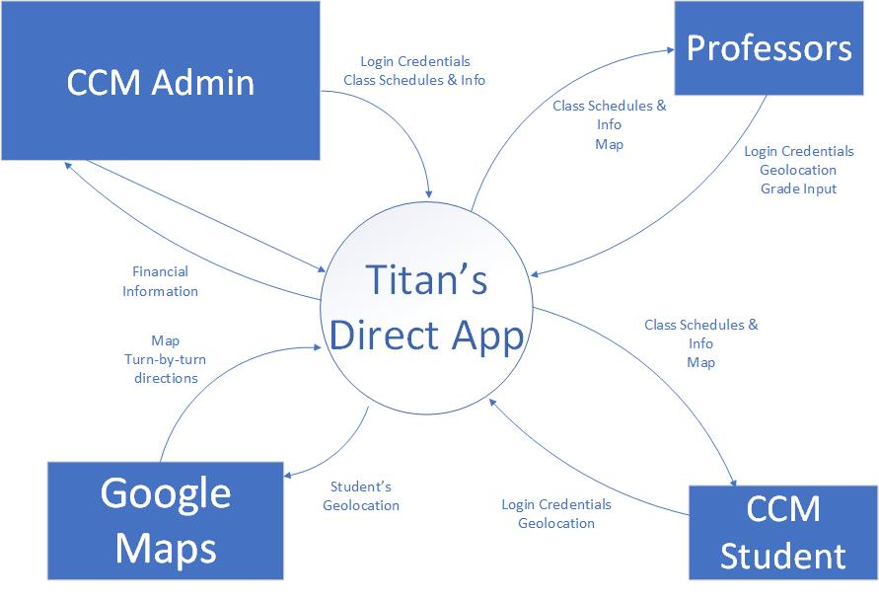

# 2. Schedule

(AL)

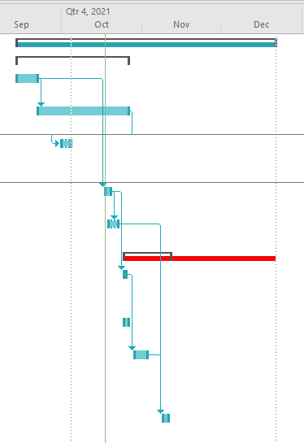

# 

# 3. Staff Organization

## a. Team Structure

(DM)

Kyle Green- Project Lead, Public Relations, Assistant Programmer

Devon McLean- Visual Effects, Project Editor, Assistant Programmer

Alexander Lindemann- Project Scheduling, Systems Development, Primary Programmer

# 4. Tracking and Control Mechanisms

(DM)

The team will be using a Trello board to monitor progress and track changes to the project in general. All code for the project will be shared through Github and all other documents will be created, updated, and distributed through a Google Drive folder that is shared between the group members. Group meetings will be held every Monday at 4:00 PM EST. Updates to the Gantt and PERT charts will be shared via email should the need arise.

Trello Board Link: <https://trello.com/b/dwx3qzdS/titans-direct-app-board>